**DOCKER COMMANDS**

1)–version: It is used to get the current version of the docker.

Syntax: docker –version (or) docker version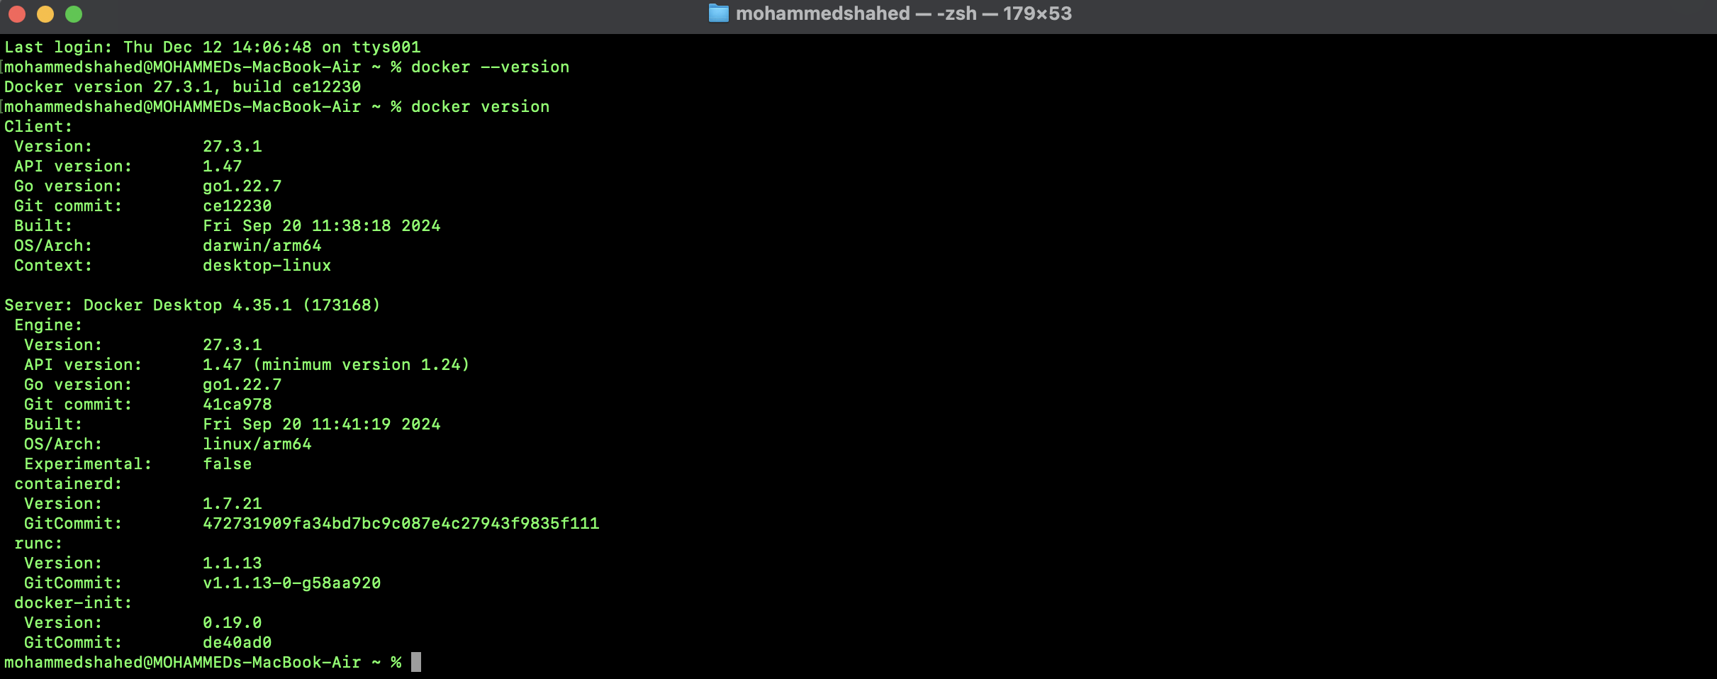

2)images: Docker Image is an executable package of software that includes everything needed to run an application.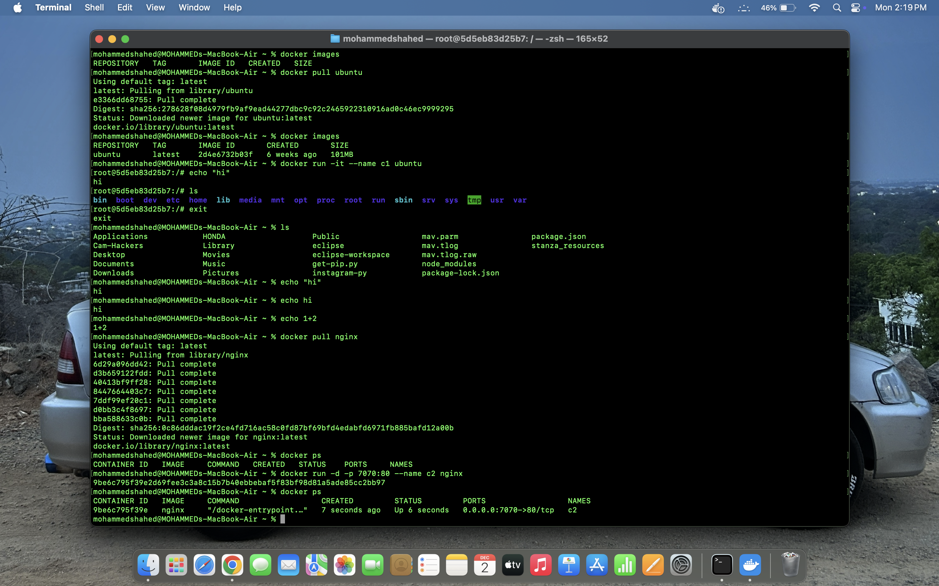

3)pull: The docker pull command is used to download Docker images from a registry. Here we have pulled ubuntu and nginx.

4)run: The docker run command runs a command in a new container, pulling the image if needed and starting the container.

5) echo: echo is a command that outputs the strings that are passed to it as arguments.-

6)ls: It returns all the files in the present working directory.

7)exit: It comes out from the loop.

8)run (giving local host): Give the local host as shown in the below picture.

Creating a container by using the below command- “docker run -d -p {port} –name {container name} {os}

-d: detached mode

-p: port mapping

Type the local host number that you have given above in the chrome and the following page will be opened.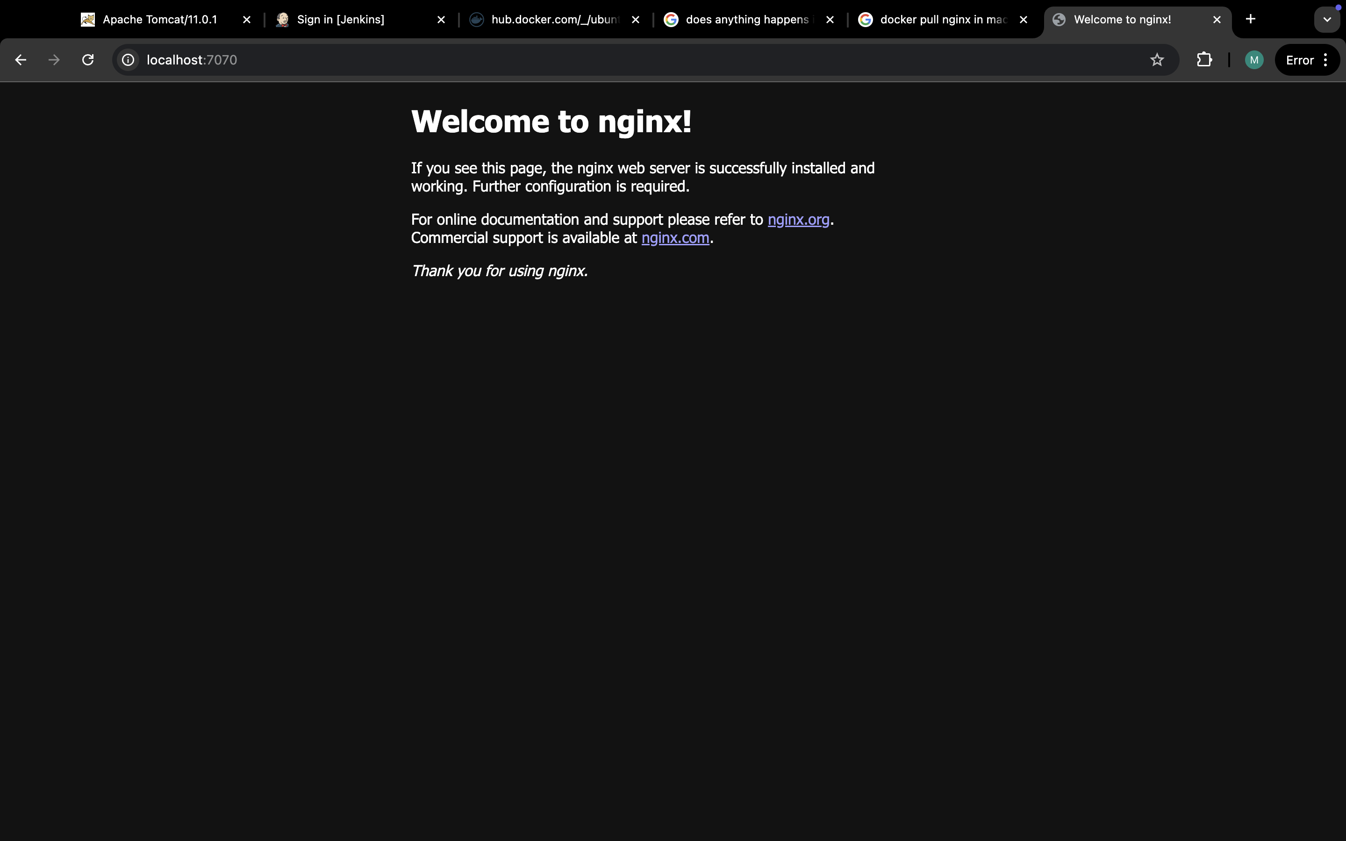

9)ps: docker ps command is used to list all the running containers in the docker host.

10)pulling tome: Pull the tome(tomcat) and give the localhost number by run command.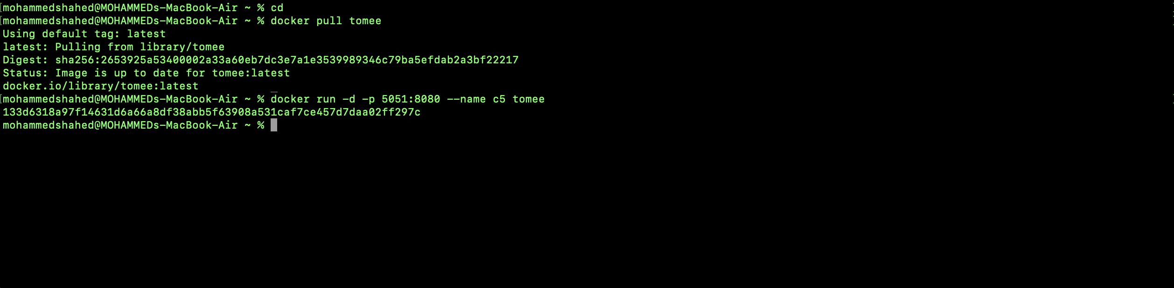

Type the localhost number that you have given above and the following page will be opened.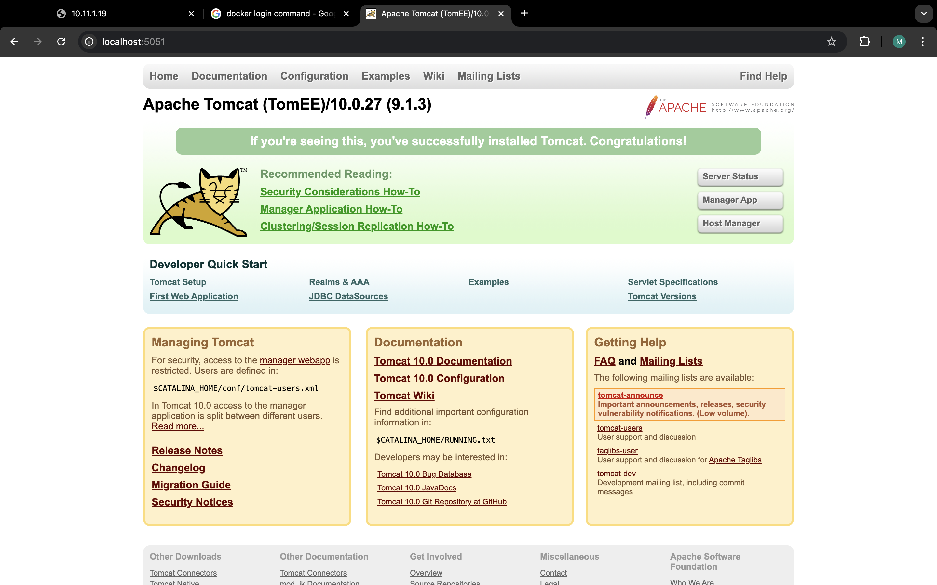

11)ps: We can see that tome and nginx are pulled.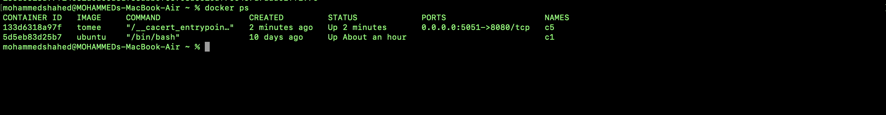

You can see the containers that you have created.

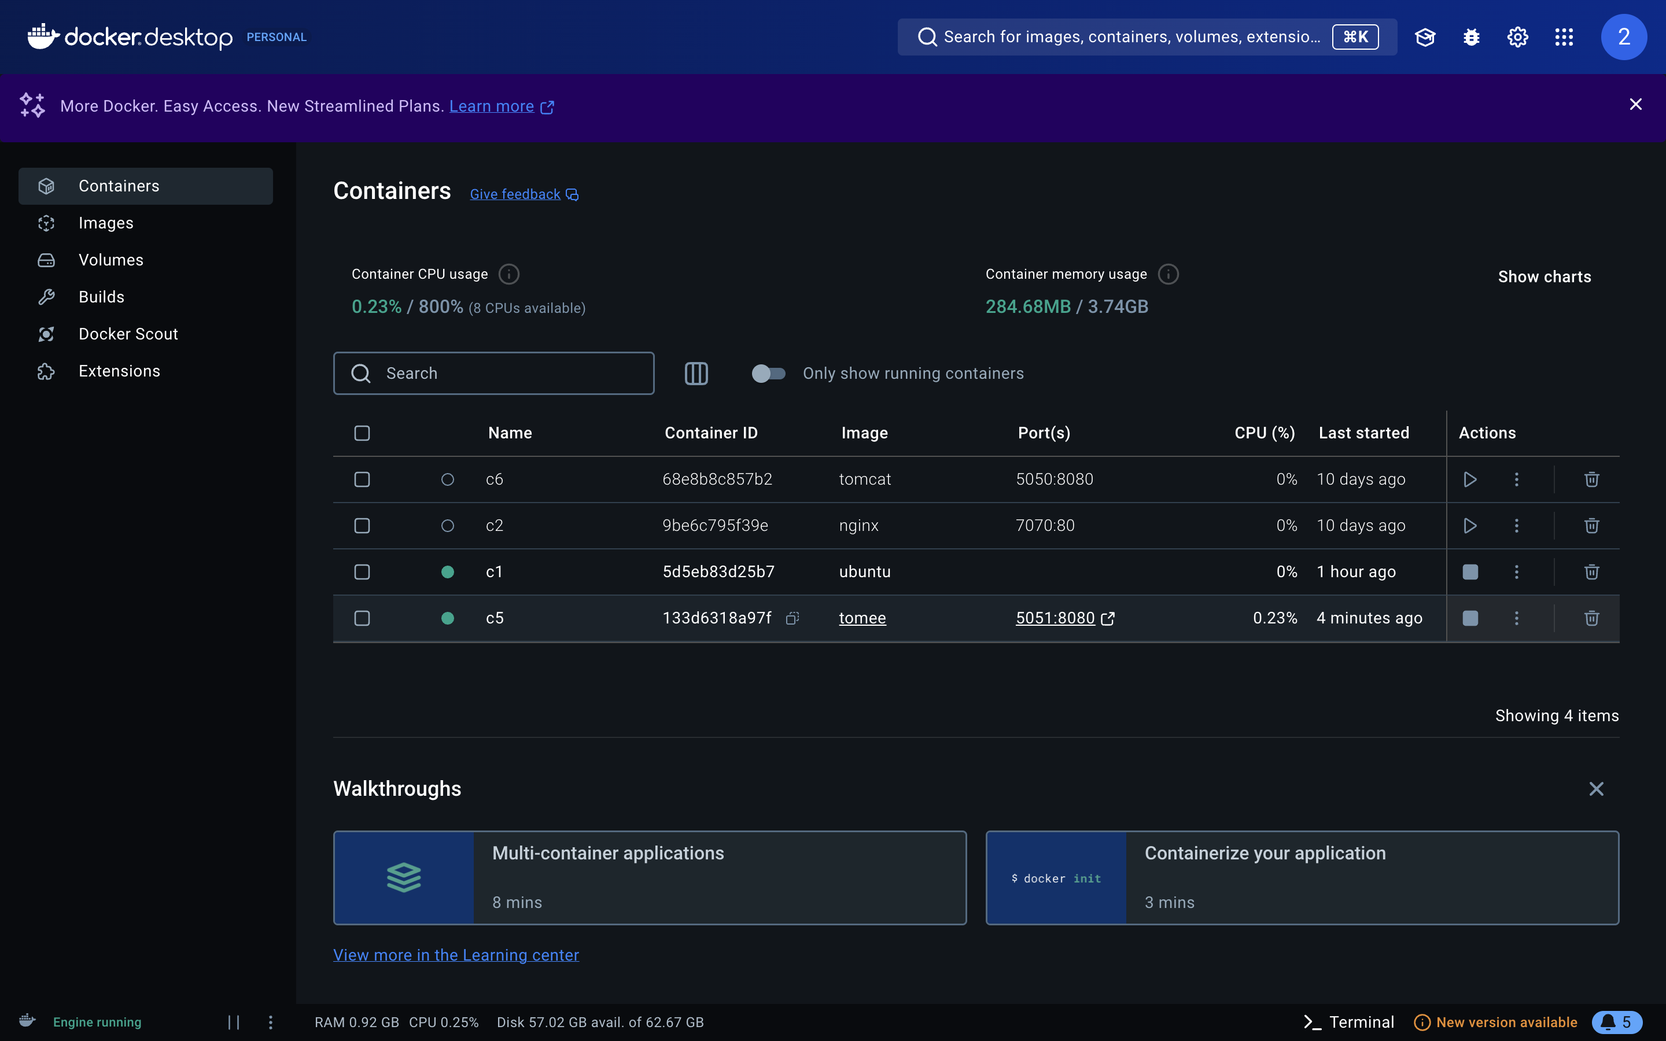

12)ps -a: This command lists all the containers on your system including running, stopped and exited containers.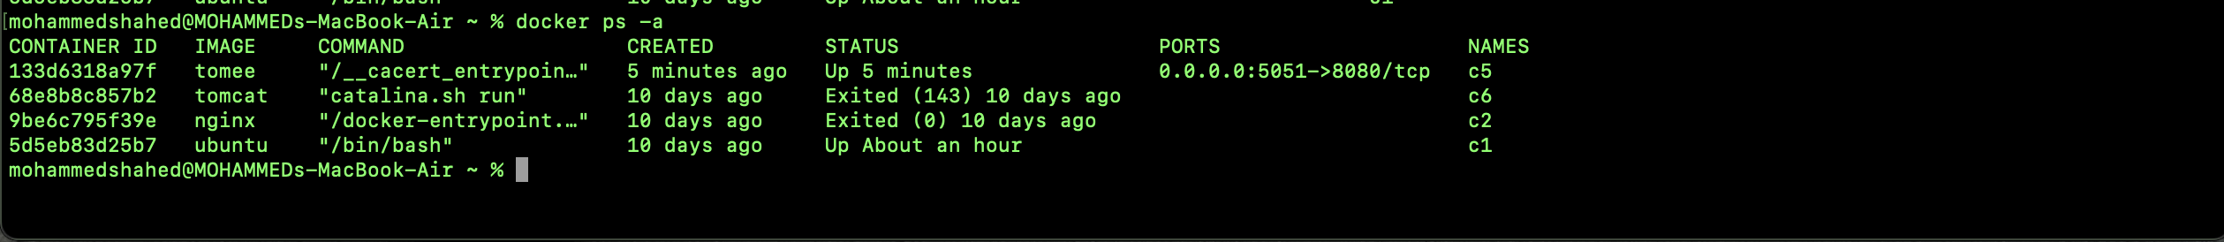

13)start: The docker start command is used to start a stopped container in Docker. It will not create a new container but will resume a previously created or stopped one.

14)exec -it: The docker exec -it command is used to run a command interactively inside a running container.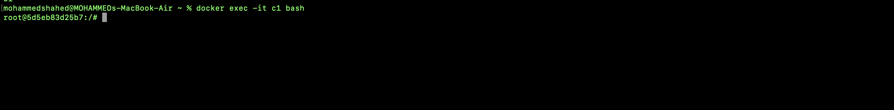

15)apt-get update: The apt-get update command in Docker is used to update the package lists from the repositories inside a container's operating system.

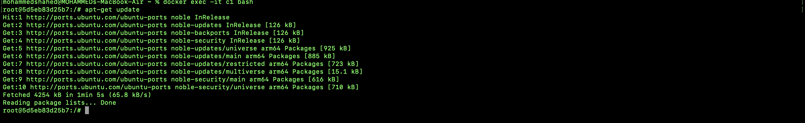

16) apt-get install: The apt-get install command in Docker is used to install packages within a container's operating system.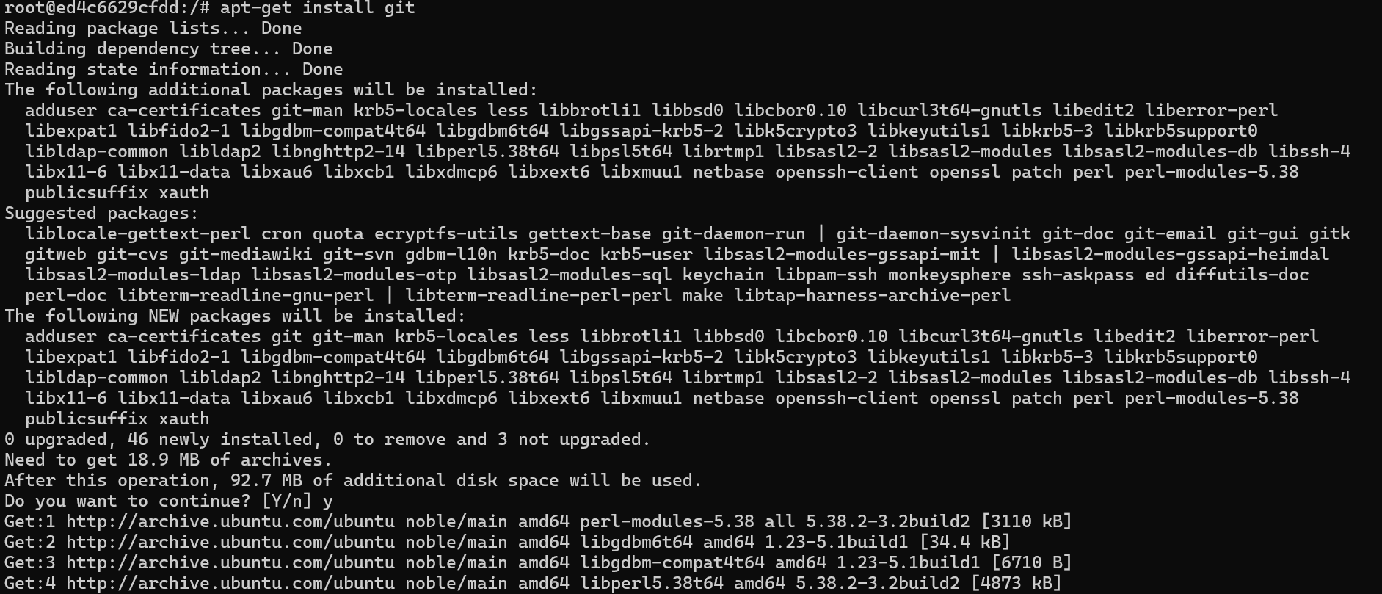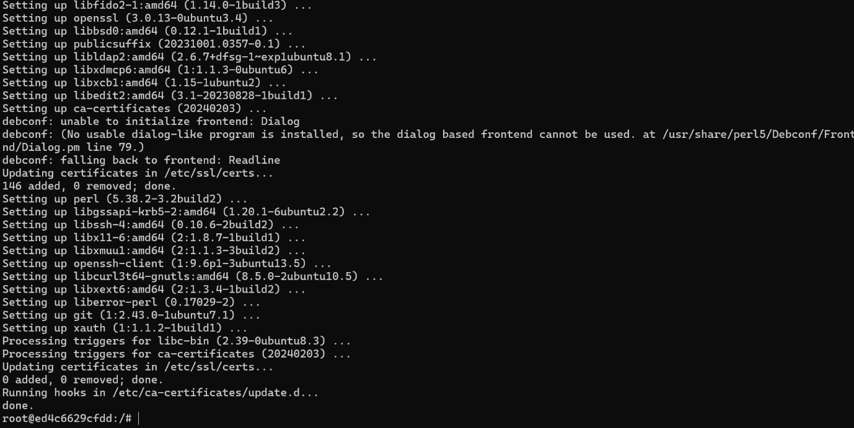

After the installation of git within the container check the version by typing the command “git –version”.

17)mkdir: This command is used to create a directory.

18)cd: This cd command stands for "change directory" is used to navigate between directories in a file system.

19)git init: This command initializes a new Git repository in the specified directory. When executed inside a Docker container, it creates a .git folder in the directory, marking it as a Git repository.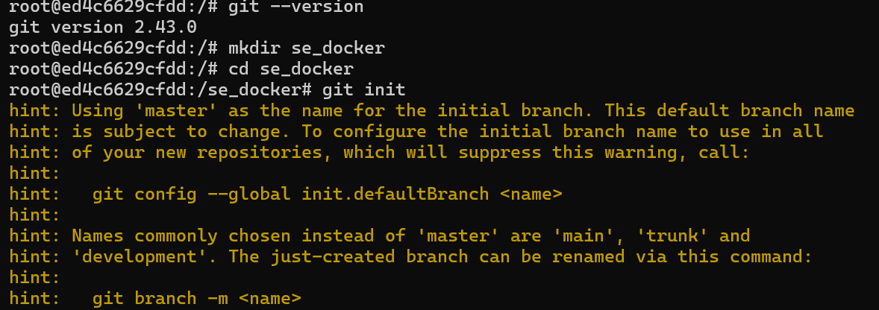

The below command is used for installing nano with the help of following command – “apt-get install nano”.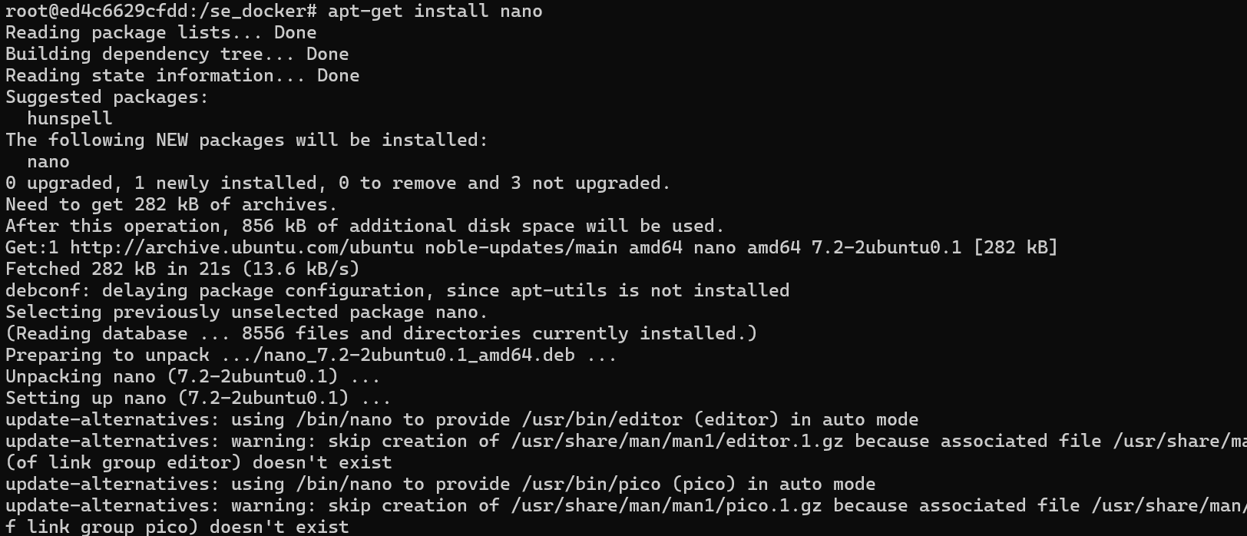

20)nano: The nano command is used to open the Nano text editor, a simple and easy-to-use command-line text editor for Unix-like systems. It is commonly used for creating and editing text files directly in the terminal.



21)ls: This command list outs all the files and directories. 

For creating image there are two ways—

* commit
* Dockerfile

**CREATING AN IMAGE USING COMMIT AND PUSHING INTO DOCKER HUB**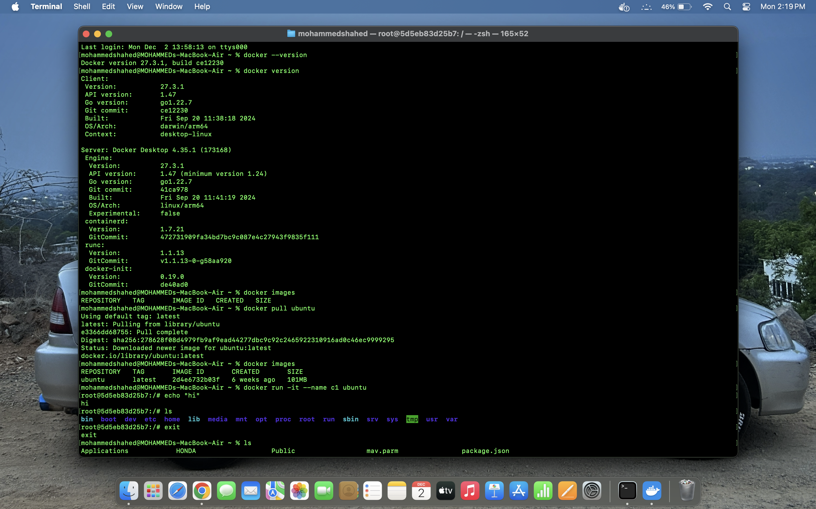



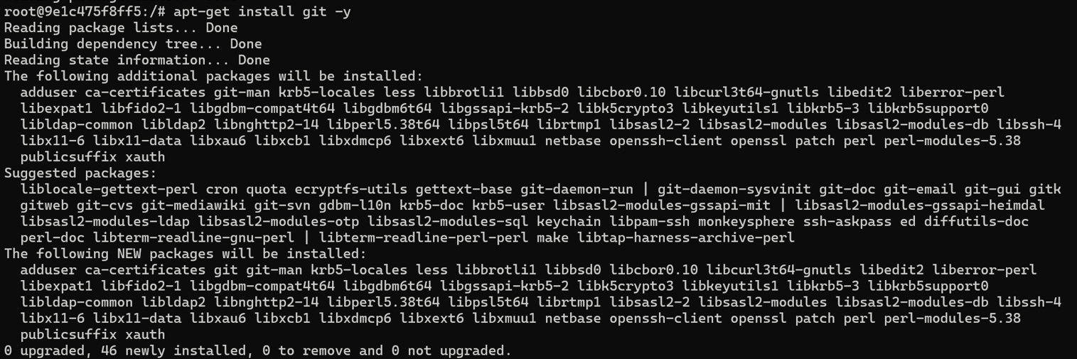

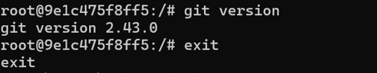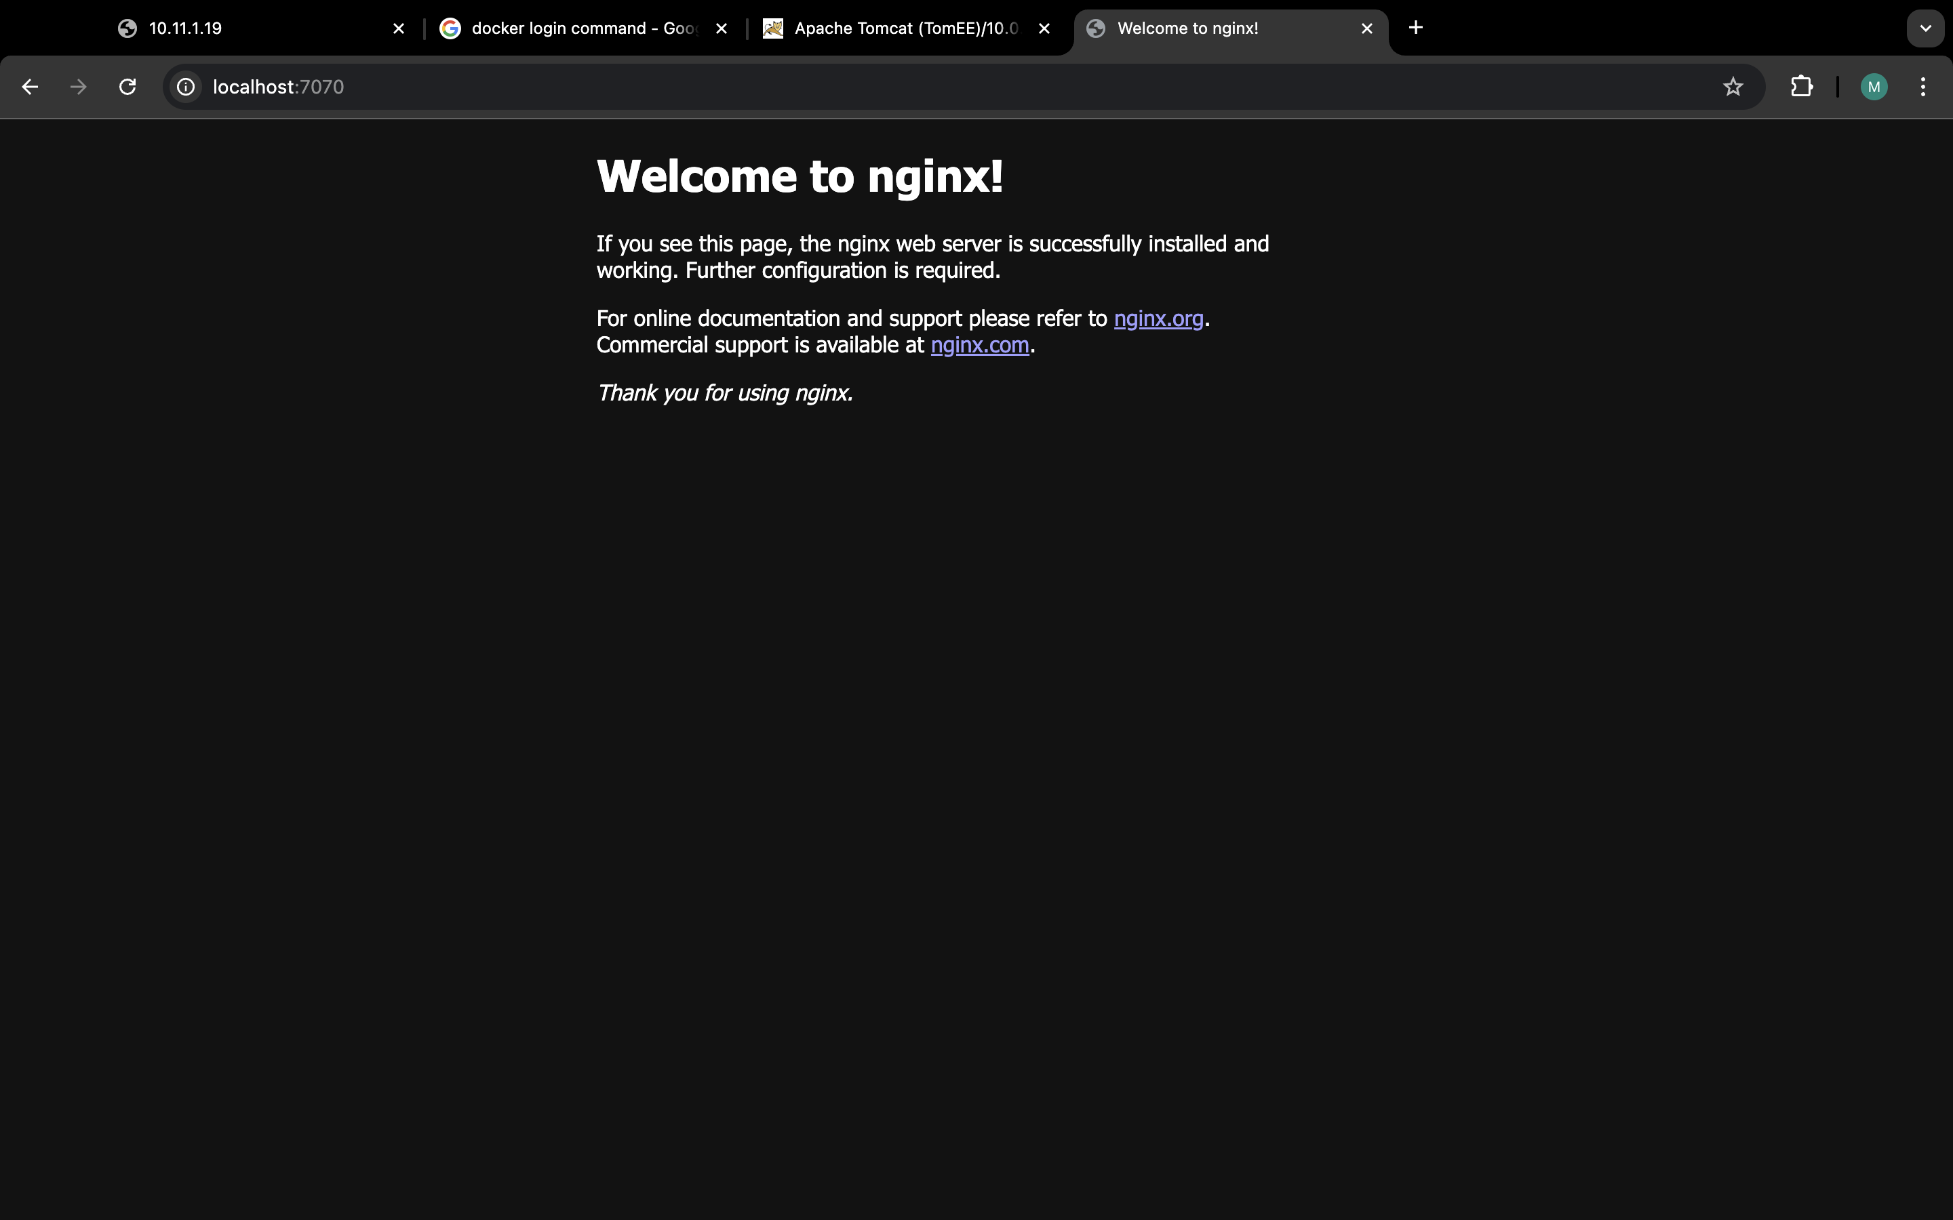

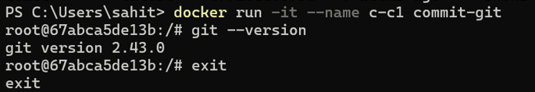

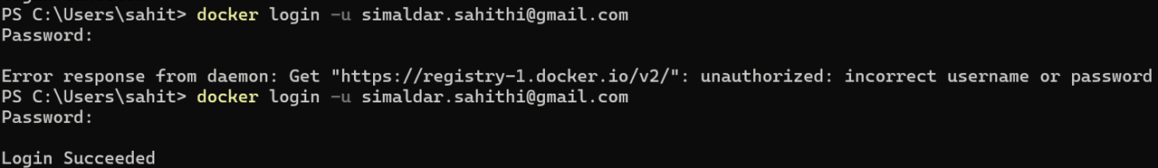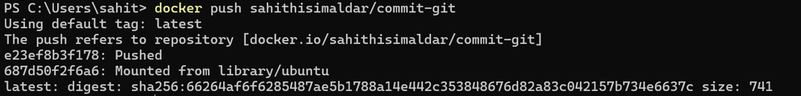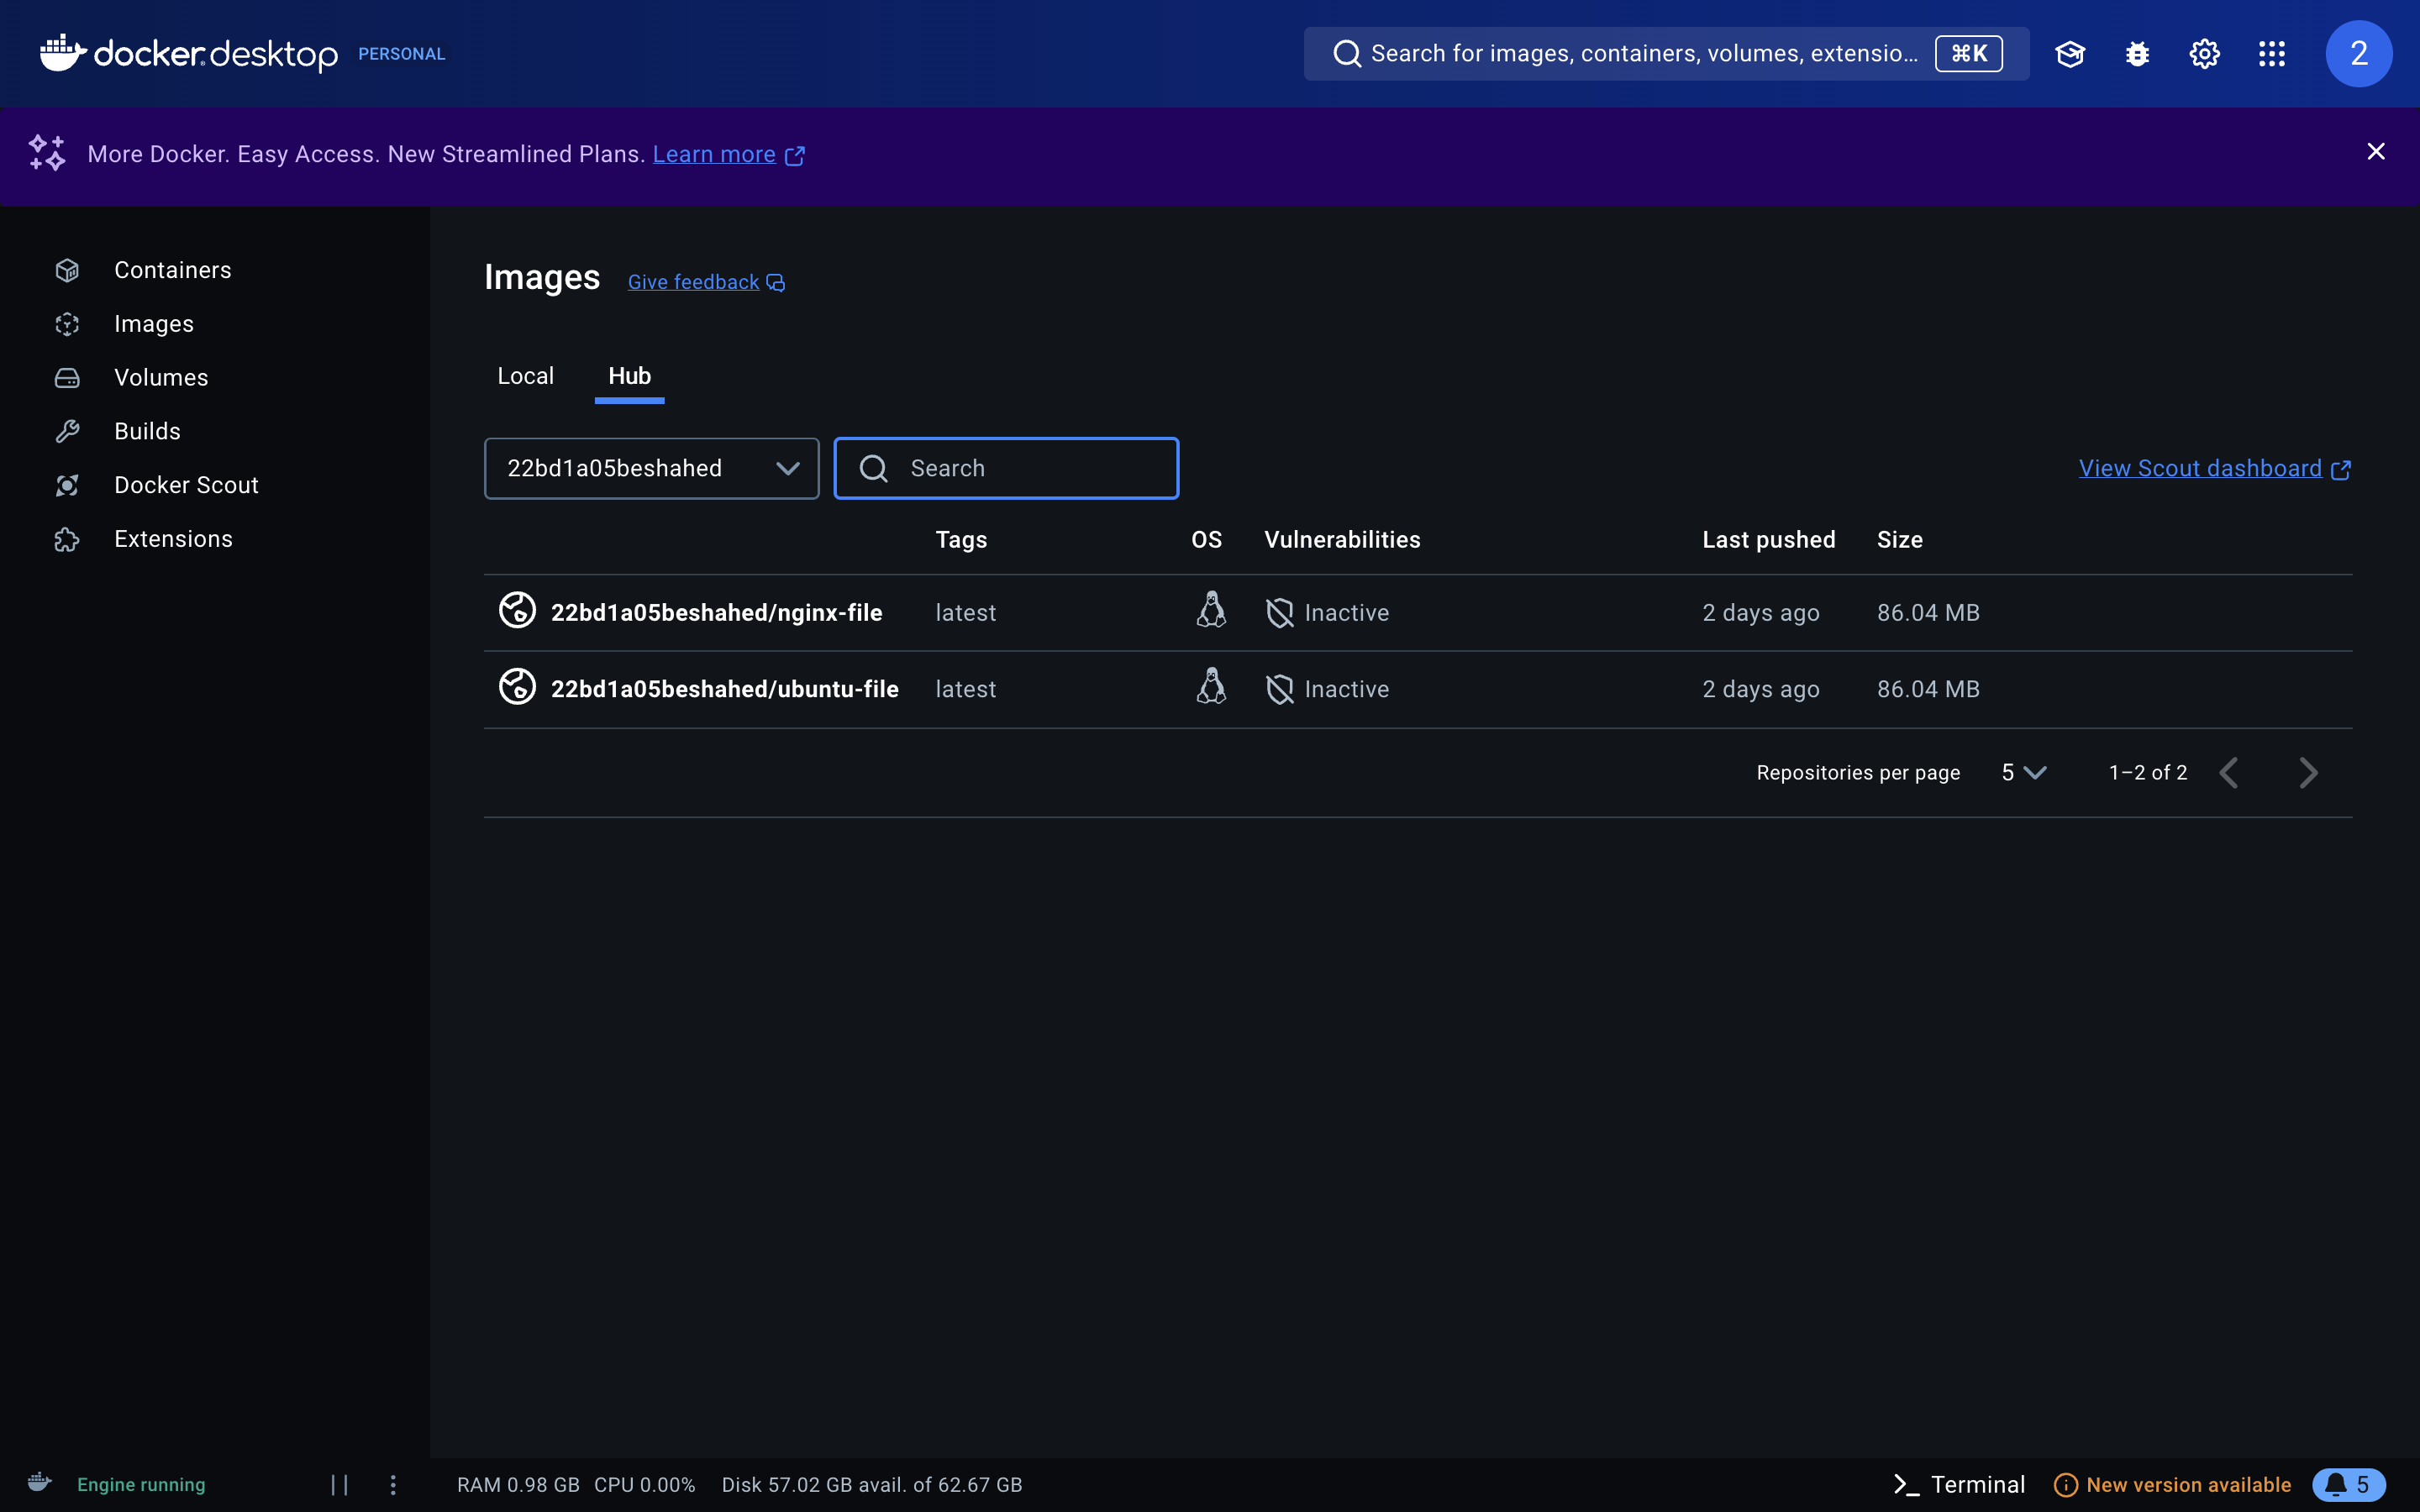

**CREATING AN IMAGE USING DOCKERFILE AND PUSHING INTO DOCKER HUB**

